Chapter No :3

System Design
System design lies at the core of the software engineering process and is applied regardless of the software process model that is used for development. Design simulation serves as the foundation in the computer based development is a time consuming task. Beginning from computer based system requirements analysis, system design is the first of three technical activities i.e., design, code generation and test that are required to build and verify the validate computer based system. The major goals of the design phase are the creation of a system that provides certain predefined functions, reliability of system, flexibility, maintainability, efficiency and security. After the comprehensive study of the existing system, then the developer designs a new system, which fulfills all the requirements of the organization. Design is only way that we can accurately translate a company and customer’s requirements in to a computer based system. Computer base system design serves as the foundation for all software engineering and maintenance steps. Design phase is compiled with the objective of reducing the problems present in the existing system.
The design of the project is user friendly. The names of database tables and fields are simple and easy to understand. In database design, the database tables and fields are developed after careful consideration of existing system to avoid redundancy and hence the errors. User interface is designed very carefully by keeping in mind the ease of user. Any new user can easily understand the system. System provides security to prevent illegal access. The interface design describes how the computer based system communicates within itself, to systems that operate with it, and with humans who use it. An interface implies a flow of information. This phase deals with the design of system which consists of following design considerations:
- Software Design
- Database Design
- User Interface Design
3.2 System Design using UML
UML is a standard that has been adopted by majority of the industry as well as the standards governing boards such as ANSI and the Object Management Group (OMG). UML allows people to develop several different types of visual diagrams that represent various aspects of the system. Rational Rose supports the development of the majority of these models, as follows:
- Use Case Diagram
- Sequence Diagram
- Activity Diagram
- Collaboration Diagram
3.2.1 Use Case Diagrams
Use Case diagrams show the interaction between use cases, which represent system functionality, and actors, which represent the people or systems that provide or receive information from the system. Use cases represent the requirements of the system from the user’s perspective. So, use cases are the functionality that the system provides. Actors are the end users of a system.
3.2.2 Sequence Diagrams
Sequence diagrams are used to show the flow of functionality through a use case. Actors and objects are shown at the top of the diagram. Each arrow represents a message passed between actor and object or object and object to perform the needed functionality. It depicts the objects and classes involved in the scenario and the sequence of messages exchanged between the objects needed to carry out the functionality of scenario.
3.2.3 Activity Diagrams
Activity diagrams are used to show the flow of an activity. Each action is shown at the top of the diagram. Each arrow represents a message passed between actor and object or object and object to perform the needed functionality. It depicts the objects and classes involved in the scenario and the sequence of actions between the objects needed to carry out the functionality of scenario.
3.2.4 Collaboration Diagrams
A collaboration diagram is an alternate way to show a scenario. This type of diagrams show object interactions organized around the objects and their links to each other. Collaboration diagrams show the same information as sequence diagrams, but people look at Collaboration diagrams for different reasons. Quality assurance engineers and system architects look at these to see the distribution of processing between objects.

Use Cases Diagram

Main Use Case:
Login
Add Info
Search
View info
Reports

End User

Use Case Admin:
Add Patient
Add Doctor
Edit Info
Delete Info
View Info
Reports

End User

Use case Doctor:
Add Prescription
Add Patient Test
Edit Info

Login
View Info

Search Info

End User

Use Case Emergency Patient:
View Prescription
View Tests
View History

Reports

Login
View Info

Search Info

End User

Sequence Diagrams

User
GUI
Database
Open Form
Give Information
Validated
Saved
Saved
Patient registration
Sequence Diagram of Patient Registration

User
GUI
Database
Open Form
Criteria
Modified/Saved
Saved
Modify Patient Record
Search
Results
Sequence Diagram of Modify Patient Record

User
GUI
Database
Open Form
Give Information
Validated
Saved
Saved
Doctor
Registration
Sequence Diagram of Doctor Registration

User
GUI
Database
Open Form
Criteria
Modified/Saved
Saved
Modify Doctor Record
Search
Results
Sequence Diagram of Modify Doctor Record

User
GUI
Database
Open Form
Criteria
Delete/Saved
Saved
Delete Doctor Record
Search
Results
Sequence Diagram of Delete Doctors record
User
Enter ID Password & Type
Give Information
Send Request
Login
Database
DBMS
Response
Incomplete information
Match Record
Receive information
Sequence Diagram of User Login

User
GUI
Database
Open Form
Give Information
Validated
Saved
Saved
Add Patient Prescription
Sequence Diagram of Add Prescription

User
GUI
Database
Open Form
Give Information
Validated
Saved
Saved
View Information
Sequence Diagram of View Information

User
GUI
Database
Open Form
Give Information
Validated
Saved
Saved
View Report
Sequence Diagram of Print Information

Start
Open option menu and select
Create option
Enter user name and password
User Account Created
Successful
Verify Entered Information Pass
words
End
No
Activity Diagram of Create User
Start
Specific Data Entry Form Opened
Open Data Entry and select
A Data entry form
Select Specific Operation to Add, Search, and Update |Data
Successful
Successful
End
Activity Diagram of All Data Entry Information
Start
Change Password
Open option menu and select
Change password option
Enter old and new password
Change password
Successful
Successful
Verify Old & New Pass
words
End
No
Activity Diagram of Change Password

3.3 Database Design:
In the design phase the most important process id database design. In database designing different normalized tables are formed then relationship between these normalized tables is described. After studying the existing system it is decided to develop normalized tables for the database design. Before describing the tables it is better to understand the concept of Normalization and the different forms of normalization.
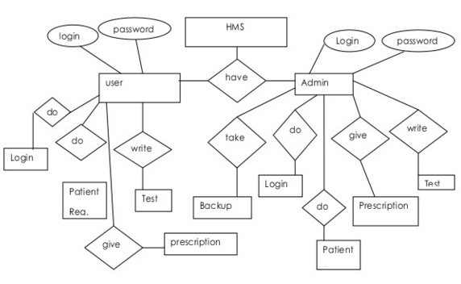
    - Entity Relationship Diagram (ERD)

ERD
    - Normalizing Relational Model to 3NF
The purpose of the normalization is to produce a stable set of relation that is faithful model of the operation of the enterprise. By following the principles of normalization we can achieve a design that is highly flexible, allowing the model to be extended when needed to account for new attributes, entity sets and relationships. We can also reduce redundancy in the database and ensure that the design is free of certain update, insertion and deletion anomalies.
Normalized Tables:
Departments Table
Primary Key: id
Purpose: This table stores the information about different departments of hospital.

Structure
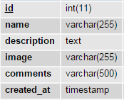
Table Name: Departments
Diseases Table
Primary Key: id
Purpose: This table stores the information about different diseases.
Structure:
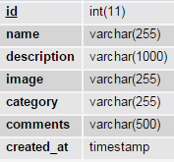
Table Name: Diseases
Users Table
Primary Key: id
Purpose: This table stores information about users.
Structure:
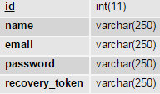
Table Name: Users

Doctors Table
Primary Key: id
Purpose: This table stores the information about doctors of the hospital.
Structure:
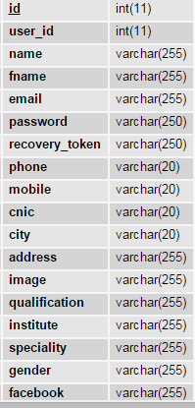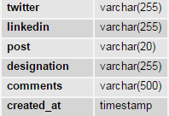

Table Name: Doctors
Doctor_disease Table
Primary Key: id
Purpose: This table stores the information about doctor specialty of diseases.
Structure:
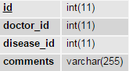
Table Name: Doctor_disease
Messages Table
Primary Key: id
Purpose: This table stores the information about appointments.
Structure:
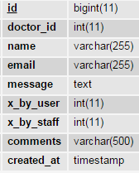
Table Name: Messages
Nurses Table
Primary Key: id
Purpose: This table stores information about of the nurses of Multan Institute of Cardiology.
Structure:
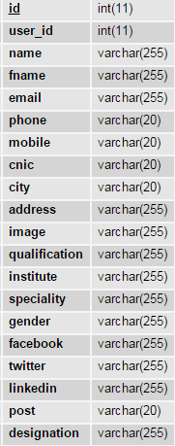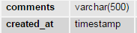
Table Name: Nurses
Options Table
Primary Key: id
Purpose: This table stores information of website contents and other key value pairs of options.
Structure:
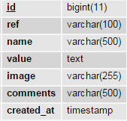
Table Name: Options
Services Table
Primary Key: id
Purpose: This table stores information about of information of the patients.
Structure:
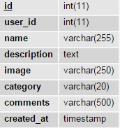
Table Name: Services
Patients Table
Primary Key: id
Purpose: This table stores information about of information of the patients.
Structure:
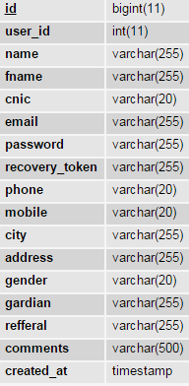
Table Name: Patients

Visits Table
Primary Key: id
Purpose: This table stores information about the visits of users to hospital.
Structure:
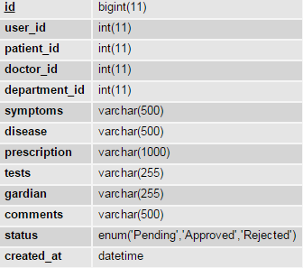

Table Name: Visits

